SIMATS ENGINEERING (SAVEETHA SCHOOL OF ENGINEERING)
Department of Computer Science and Engineering
ASSESSMENT TOOL 2 – MCQs
Course Code: | CSA06 | Course Title: | Design and Analysis of Algorithms
CO Assessed: | CO3: Articulation (BL4, BL5) | Assessment: | Assessment Tool 2 – MCQs
Weightage: | 10% of CIA | Total Marks: | 100 (50 Questions × 2 Marks)
CO3 Statement: | Design Divide and Conquer algorithms for Merge Sort, Quick Sort, Binary Search and Matrix Multiplication
Student Name: | S.MAHALAKSHMI | Reg. No.: | 192524372
Section / Batch: | 2ND YEAR | Date: | 20/08/26

Instructions to Students
- Answer all questions carefully. Each question carries 2 marks. Total: 100 marks.
- Analyze each question and select the correct answer.
- Apply concepts correctly to solve problem-based MCQs.
- Manage your time efficiently to complete all 50 questions.

Question Type | Description | Questions | Total Marks
MCQs | Analyze and apply Divide and Conquer Algorithms for Merge Sort, Quick Sort, Binary Search, and Matrix Multiplication. | Q1 – Q50 | 100

SECTION A – MCQs

MCQ Link : --------------------------------------
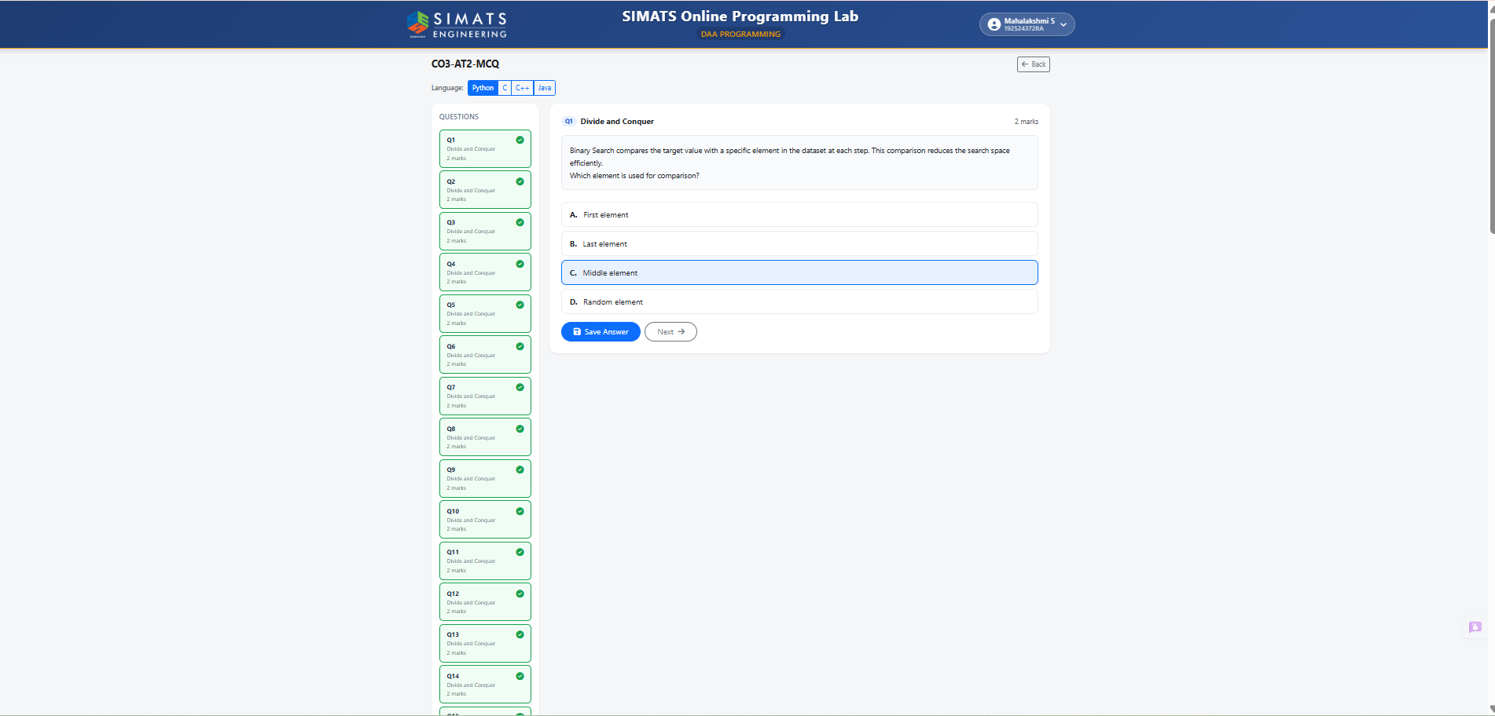
Code of Conduct
I S,MAHALAKSHMI(192524372)_______________________ (Name / Reg No) certify that this submission is my original work and that I have adhered to the guidelines specified for this assessment. I understand that any violation of academic integrity rules will result in disciplinary action.
Signature of the Student: S.MAHALAKSHMI_________________________

RUBRICS FOR CALCULATION
Online Quiz / MCQ Test
Criteria | Weightage (%) | Level 4 (Exemplary) | Level 3 (Proficient) | Level 2 (Developing) | Level 1 (Beginning)
Conceptual Understanding | 30% | Demonstrates thorough understanding; answers all questions accurately | Shows good understanding with few errors | Partial understanding; several incorrect responses | Lacks understanding; majority of answers incorrect
Accuracy of Answers | 25% | All answers are correct | Most answers are correct with minor mistakes | Some correct answers; frequent errors | Mostly incorrect answers
Application of Knowledge | 20% | Correctly applies concepts to problem-based questions | Applies concepts with minor errors | Limited ability to apply concepts | Unable to apply concepts
Time Management | 15% | Completes quiz well within time efficiently | Completes on time with minor delays | Requires extra time or rushes through questions | Unable to complete within given time
Question Interpretation | 10% | Interprets all questions correctly and responds appropriately | Misinterprets a few questions | Often misinterprets questions | Unable to understand questions
Mark Evaluations:
No. of MCQ Questions | Correct Answers | Wrong/Not Answers | Total Marks  (100)
50

Faculty In-charge | Course Coordinator | Head of Department
Name: __________________  Signature: _______________ | Signature: _______________ | Signature: _______________
Date: ___________________ | Date: ___________________ | Date: ___________________

